**WEEK 6**

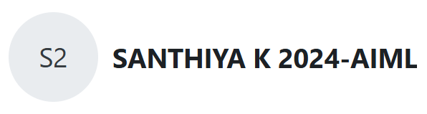

**Question 1:**

1. **You are given a sequence of n-1 distinct positive integers, all of which are less than or equal to a integer ‘n’. You have to find the integer that is missing from the range [1,2, . . . n]. Solve the question without using arrays.**

**Program :**

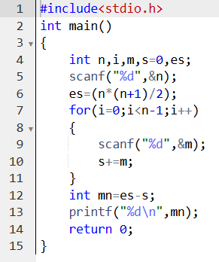

**Output :**

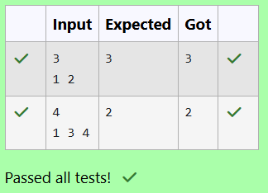

1. **A Teacher came to the class with a large box that has several coins. Each coin has a number Printed on it. Before Coming to the class, she ensured that all the coins occurs an even number of times. However, while coming to the class one coin fell down and got lost. She wants to find out the number of missing coin (Solve the question without using arrays).**

**Program :**

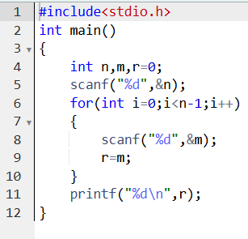

**Output :**

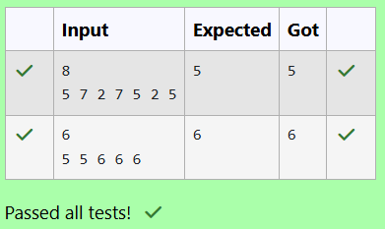

1. **An abundant number is a number for which the sum of its proper divisors is greater than the number itself. Proper divisors of the number are those that are strictly lesser than the number.**

**Program :**

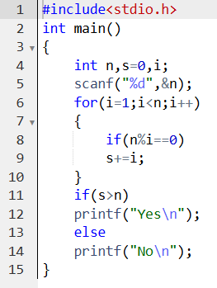

**Output :**

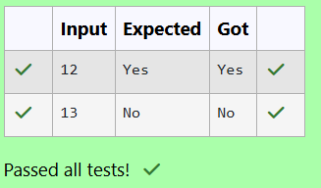

**Question 2:**

**Sample Input 1:**

**5**

**30 40 50 20 10**

**20**

**Sample Output 1:**

**Element found at location : 3**

**Program :**

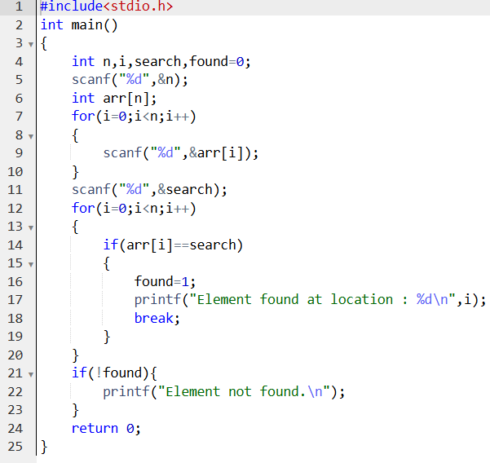

**Output :**

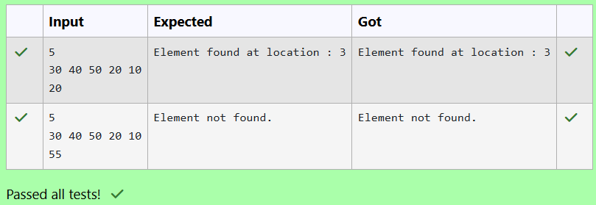

**Question 3:**

**Sample Input 1:**

**5**

**10 20 30 40 50**

**30**

**Sample Output 1:**

**Element found at location : 2**

**Program :**

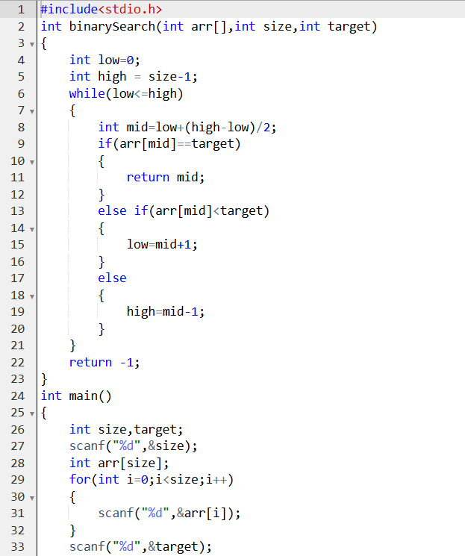

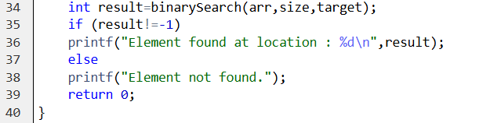

**Output :**

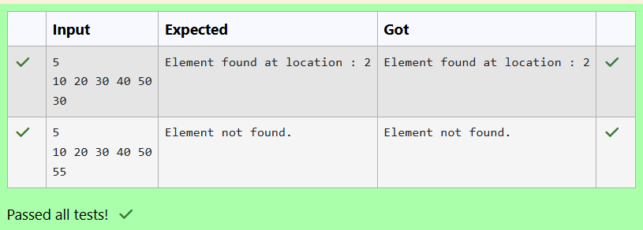

**Question 4:**

**Sample Input:**

**5  
30 40 50 20 10**

**Sample Output:**

**10 20 30 40 50**

**Program :**

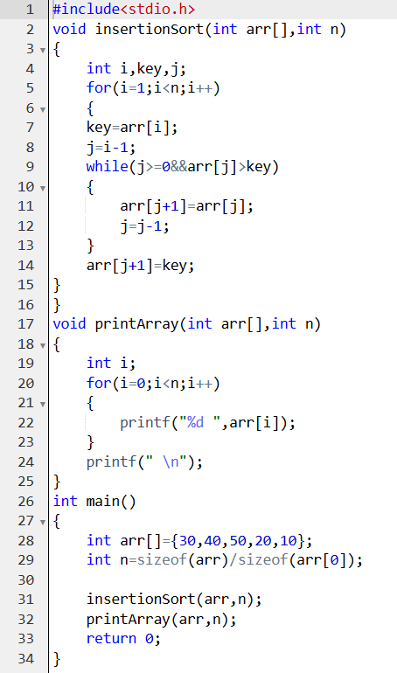

**Output :**

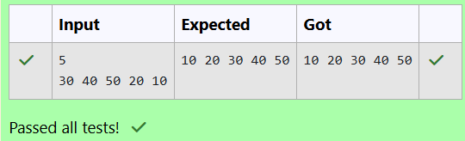

**Question 5:**

**Sample Input:**

**5  
30 40 50 20 10**

**Sample Output:**

**10 20 30 40 50**

**Program :**

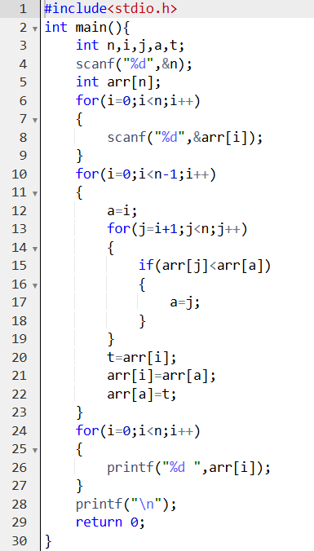

**Output :**

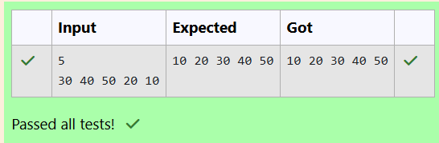

**Question 6:**

**Sample Input:**

**5  
30 40 50 20 10**

**Sample Output:**

**10 20 30 40 50**

**Program :**

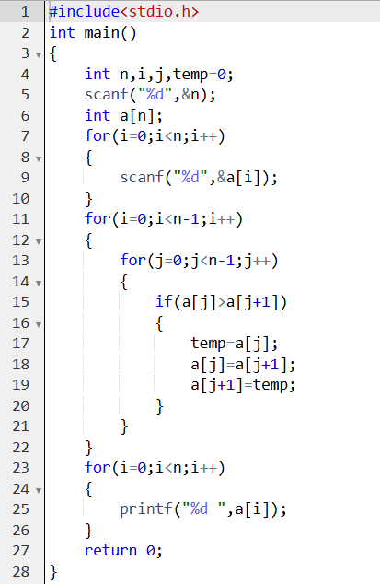

**Output :**

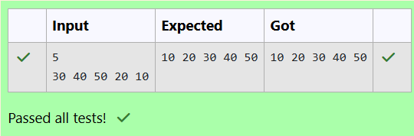

**Question 7:**

**Sample Input:**

**5  
30 40 50 20 10**

**Sample Output:**

**10 20 30 40 50**

**Program :**

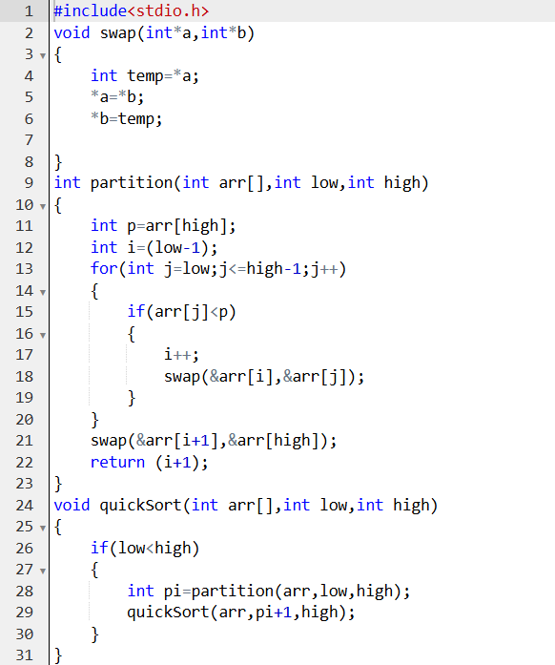

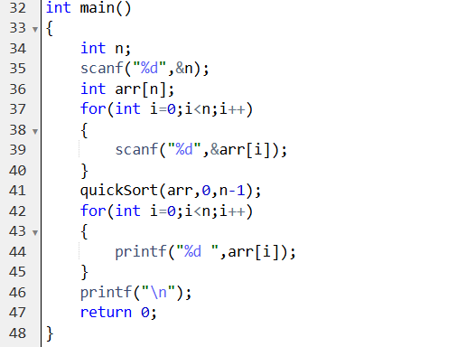

**Output :**

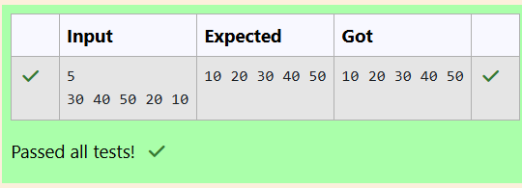

**Question 8:**

**Sample Input:**

**5  
30 40 50 20 10**

**Sample Output:**

**10 20 30 40 50**

**Program :**

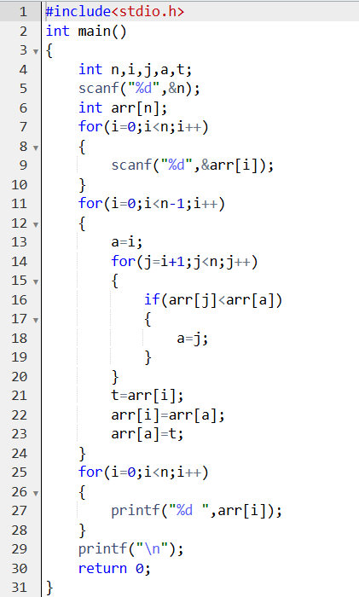

**Output :**

